CLAS12 Light Threshold Cherenkov Counter (LTCC)

WBS 2.4.2.2.4.2

Activity 242242092. Budget: $51,595

Activity 242242110. Budget: $51,595

The reflectivity of the LTCC mirrors has been measured (see Fig. 1) and found to have deteriorated by 10-15% (absolute value). For two/three reflections of the Cherenkov lights on the elliptical, hyperbolic mirrors and Winston Cones surface this deterioration corresponds to a reduction of 40% of light at the PMT face (see Fig. 2).

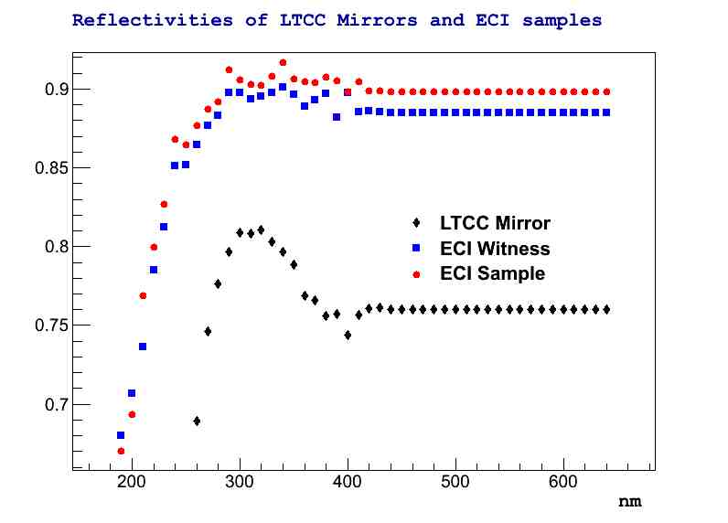

Figure 1: black: deterioration of the current LTCC mirror compared with recoated samples (blue, red)

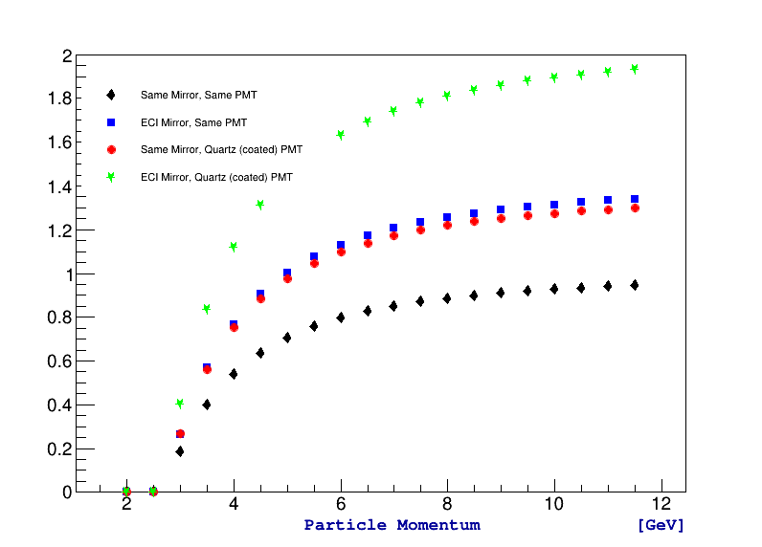

Figure 2: Blue : Improvement of light efficiency over current mirrors (black)

All estimates for mirrors and WC re-coating are based on PR 324253 and communications with Evaporated Coating Inc (ECI).

The cost per mirror is increased by 10% compared to PR 324253 due to the different sizes and dimensions.

A quote is contingent on tests.

**Activity ID** – 242242092

**Activity Name** – Al/Mg Deposit Procurement WC

Budget amount: $53,240.88

Cost per WC is $200, 36 / sectors for 6 sectors gives total cost of $43200.

**Activity Status**

Tests have been performed on 120 WC. 42 of the WC are un-acceptable and are shipped to the company. Expected return rate from ECI: 10 / week.

**Activity ID** – 242242110

**Activity Name** – Al/Mg Deposit Procurement

Budget amount: $53,240.00

Cost per mirror is about $110, 72 / sectors for 6 sectors gives total cost of $47520.

**Activity Status**

Completed on Nov. 11 2014. All lexan strips received, all mirror coated.